React Blog Application

**Objectives**

* Explain the need and Benefits of component life cycle
* Identify various life cycle hook methods
* List the sequence of steps in rendering a component

**Application Setup**

1. **Create a React App:**

npx create-react-app blogapp

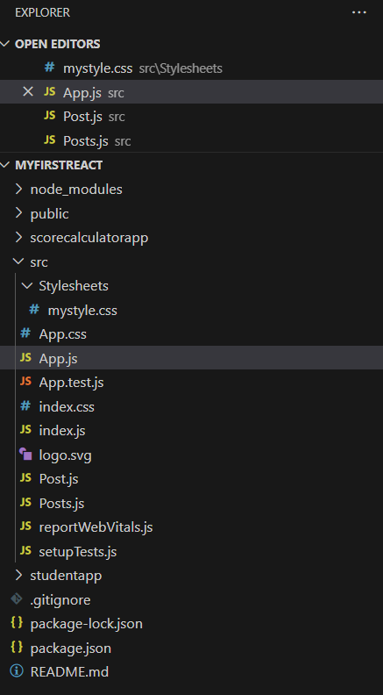

**File Structure & Components**

**Update App.js**

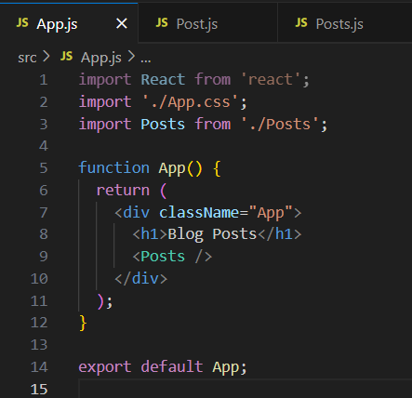

**Create Post.js in src**

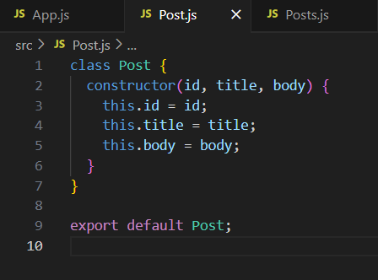

**Create Posts.js**

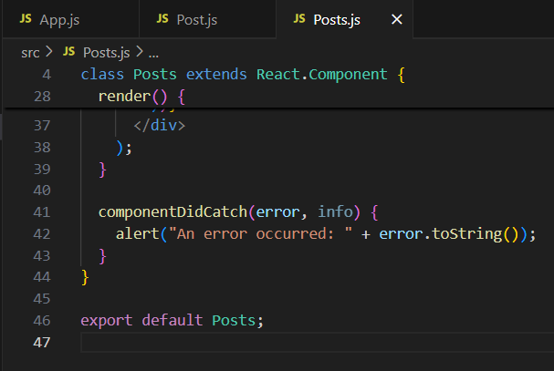

**OUTPUT**

